

LAB PROJECT

“Bench Vice Sliding Jaw”

Department of CSE
Semester: Spring 2026
Course Code: CSE 200
Course Title: Engineering Drawing
Section: 09

Submitted By: Submitted To:
Name: Arup Bhowmik Pritom Name: MAMRD
Id: 2025-2-60-330 Designation: Lecturer
Department: CSE Department: CSE

Date of Submission: 14/04/2026

Project Title:
Design and Modeling of a Bench Vice Sliding Jaw

Project Description:
Overview: This project involves the precise 3D modeling and 2D engineering drafting of a Sliding Jaw, a critical component of a standard Bench Vice. The object was selected for its geometric complexity, requiring a combination of advanced AutoCAD operations to demonstrate technical proficiency in Computer-Aided Design.
About: A bench vice sliding jaw (or movable jaw) is the dynamic, moving component of a vice that shifts forward and backward to clamp or release workpieces. It is attached to a slide that moves along the vice body, operated by a threaded screw and handle to exert pressure against the fixed jaw
Technical Details: The model was developed using a bottom-up approach, starting with a 2D profile based on standard mechanical dimensions. The primary features of this design include:
- 3D Solid Modeling: Created using EXTRUDE and UNION operations to ensure a manifold solid structure.
- Boolean Operations: Integrated slots and screw housing holes were precisely crafted using the SUBTRACT command to mimic real-world machining processes.
- Geometric Precision: The design incorporates curved profiles (fillets) and angular surfaces to ensure realistic mechanical functionality.
Drafting & Projections: To provide a comprehensive engineering view, the project includes:
- Orthographic Projections: I used 3rd Angle Projection, showcasing the Front, Top, and Side views with accurate hidden line details.
- Isometric View: 2D isometric representation to provide a clear spatial understanding of the component.
- 3D Modeling: high-fidelity 3D solid model representing the final physical form of the Bench Vice Sliding Jaw, showcasing its structural integrity and mechanical design.
- Annotations: Comprehensive dimensioning and labeling to ensure the design meets industrial documentation standards.
Software Used: AutoCAD 2023

Orthographic Projection (3rd Angle) :

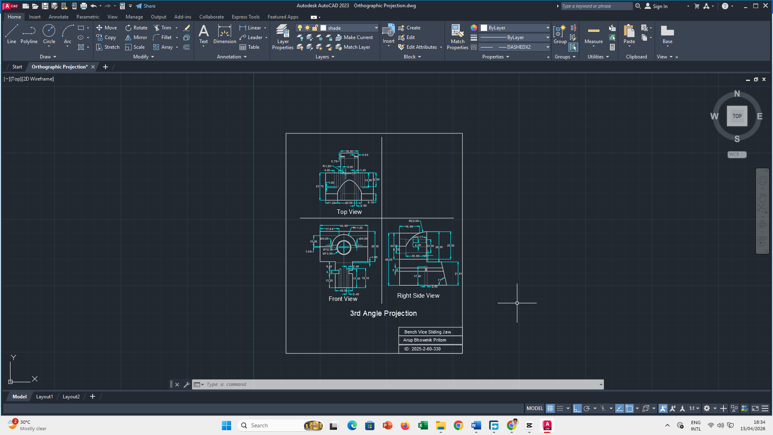
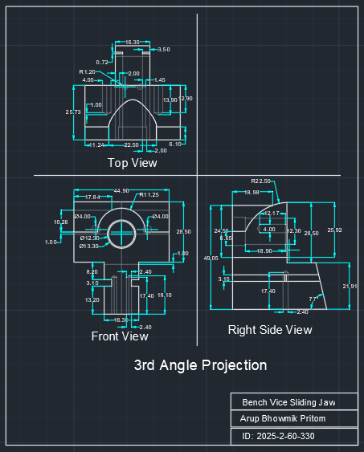

Isometric View :

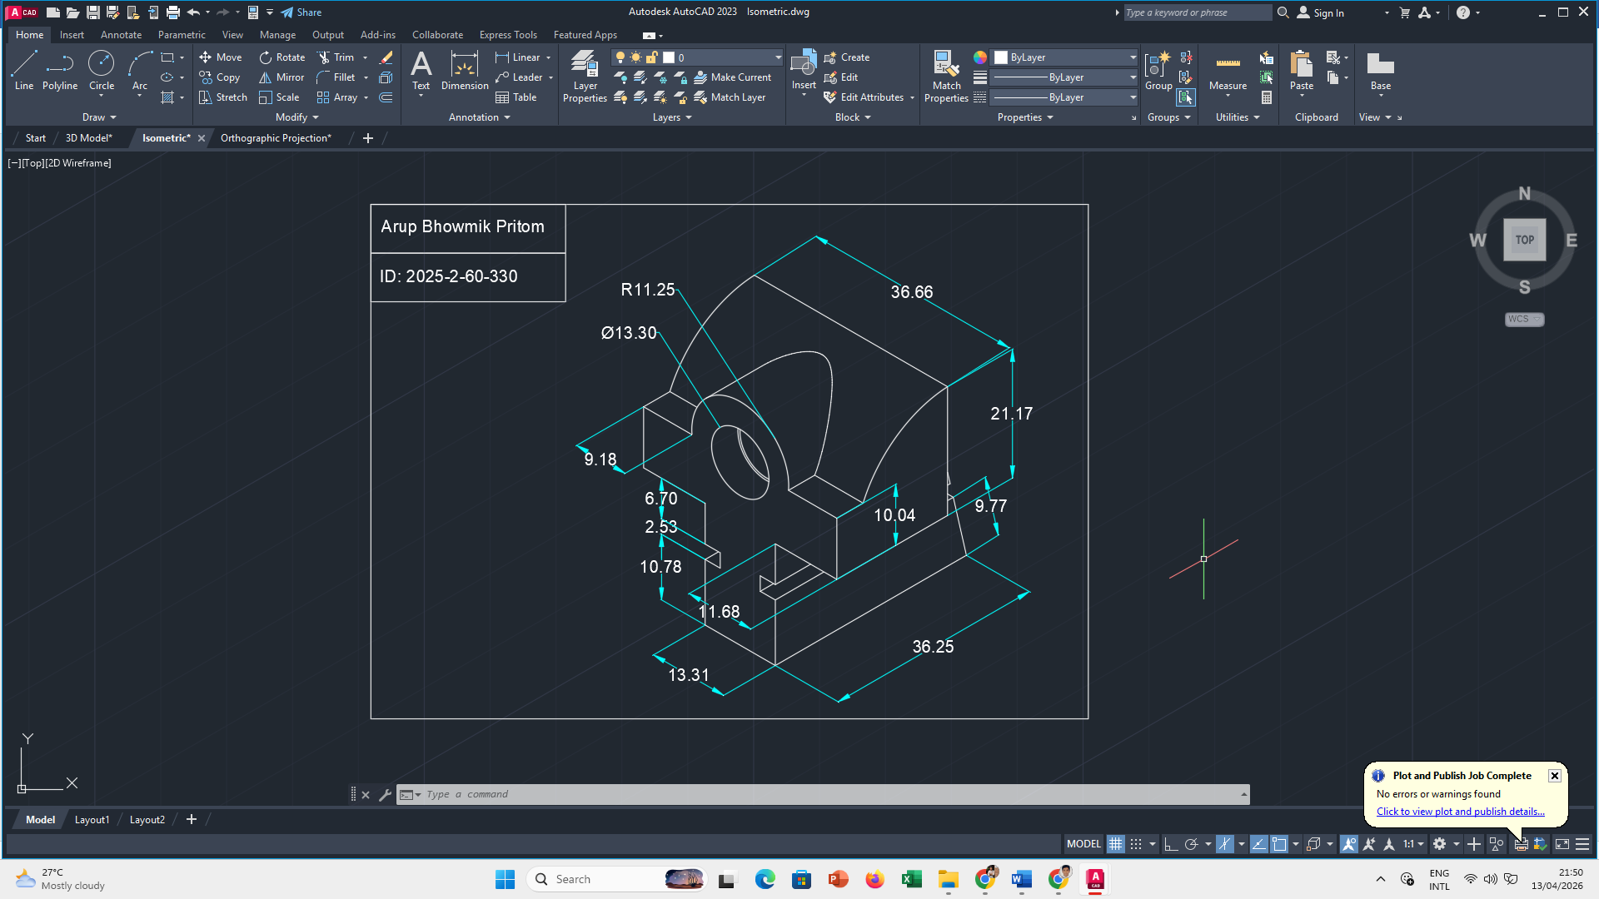

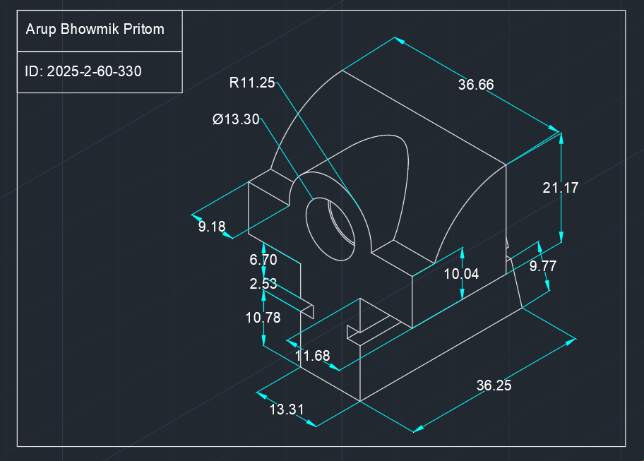

3D Model :

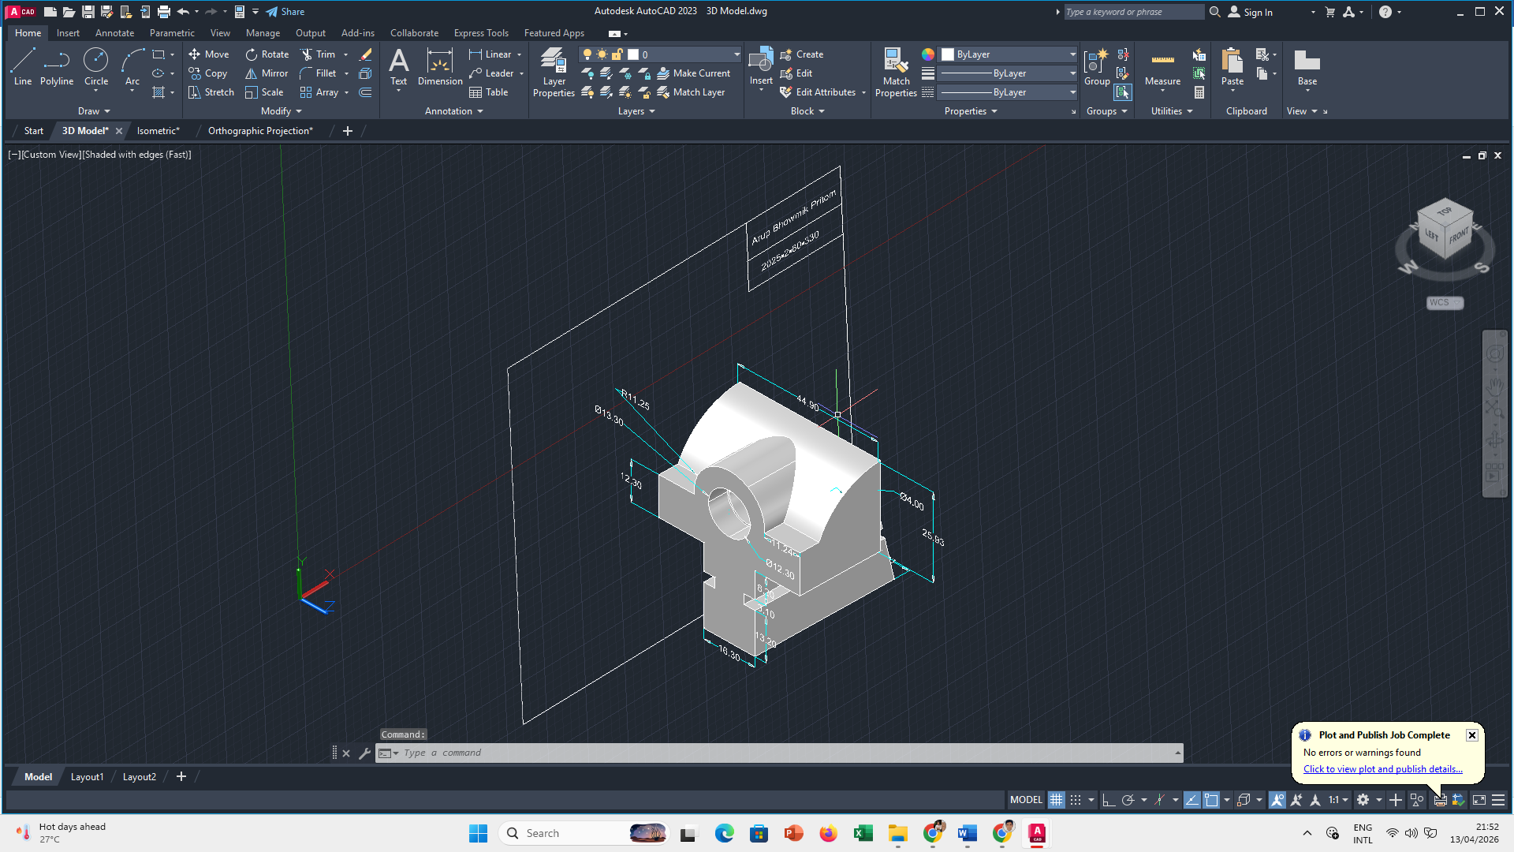
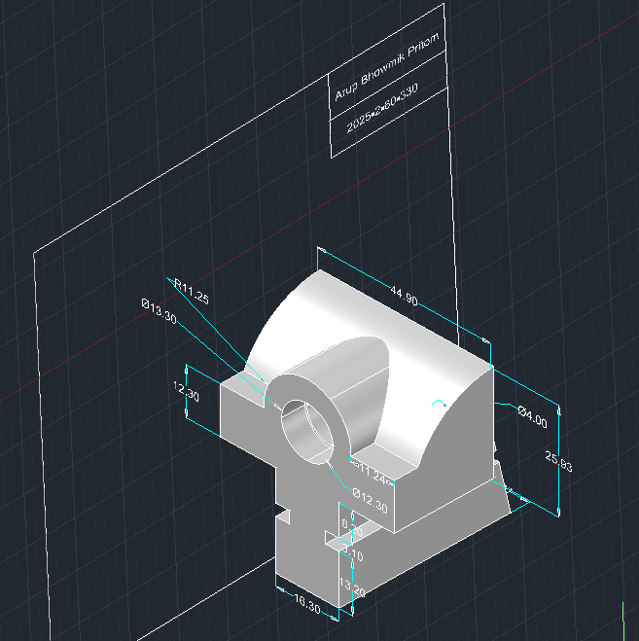

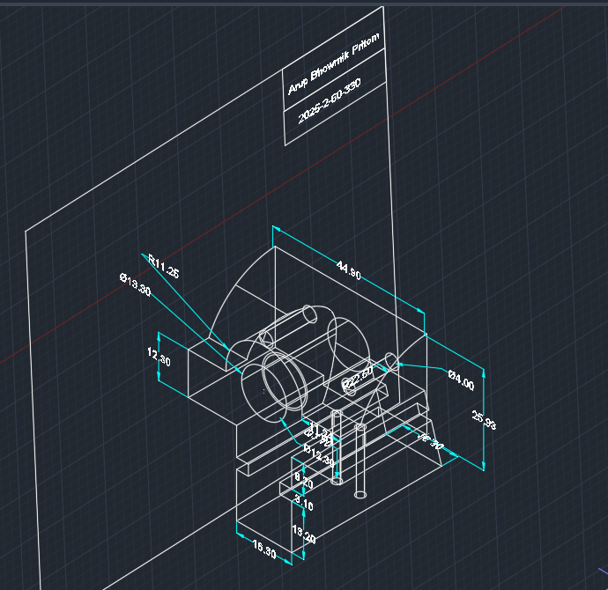

Thank You Sir

